Sentiment Analysis on Twitter Data: A Comparative Study of Machine Learning Approaches

Introduction
Sentiment analysis, a key discipline within natural language processing (NLP), focuses on identifying and categorizing opinions expressed in text data. This project aims to apply sentiment analysis to Twitter data, leveraging 10% of the Sentiment140 dataset, which includes 1.6 million tweets automatically annotated for sentiment. The primary objective is to compare the effectiveness of traditional machine learning and advanced deep learning models in accurately classifying tweets into positive or negative sentiments.

Data Processing
The preprocessing phase was critical in preparing the dataset for modeling. Key steps included:
- Text Cleaning: Removal of URLs, usernames, special characters, and numbers to reduce noise in the tweets.
- Tokenization: Breaking down tweets into individual tokens for analysis.
- Vectorization (TF-IDF): For the traditional machine learning approach, tokenized text was transformed into numerical vectors using Term Frequency-Inverse Document Frequency (TF-IDF).
For the deep learning approach (BERT), specific preprocessing steps were necessary:
- BERT Tokenization: Employing BERT's tokenizer, which handles special tokens and converts words into token IDs.
- Preservation of Special Characters: Unlike the traditional approach, BERT's tokenizer can interpret special characters, retaining the textual nuances.
A crucial aspect of data processing was ensuring class balance. Analysis revealed that the dataset was evenly distributed between positive and negative sentiments, with each class accounting for 50% of the data. This balance is vital for avoiding model bias toward the more frequent class.

Modelling
Two models were developed:
- Random Forest Classifier with TF-IDF: A traditional approach utilizing the robust and effective Random Forest algorithm, combined with TF-IDF for feature extraction.
- DistilBERT (Bidirectional Encoder Representations from Transformers): An advanced deep learning model, fine-tuned for 1 epoch on the Sentiment140 dataset, leveraging its pre-training on extensive text data.
Evaluation:
- Models were assessed based on accuracy, precision, recall, and F1-score.
- BERT outperformed the Random Forest model, showcasing its superior capacity for understanding contextual nuances in language.
- The superior performance of BERT is attributed to its transformer architecture, enabling a comprehensive understanding of bidirectional contexts within text.
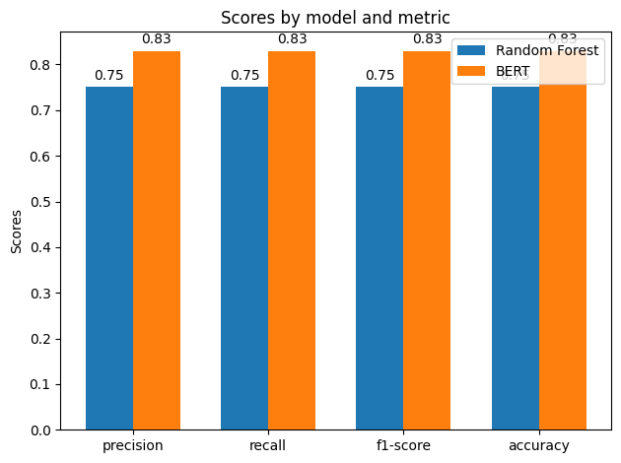
Scientific Insights:
- The effectiveness of BERT underscores the significance of context and depth in language understanding for sentiment analysis.
- The Random Forest model, while proficient, is limited by the static nature of TF-IDF vectors and lacks the dynamic contextual comprehension of BERT.
Potential for Improvement:
- Further experimentation with hyperparameters and model architectures could enhance performances.
- Advanced NLP techniques and additional feature engineering might improve the traditional model's performance.

Conclusions
This project underscored the transformative impact of transformer models like BERT in sentiment analysis, surpassing traditional machine learning techniques in understanding the complexities of language. The balanced nature of the dataset, with equal representation of positive and negative sentiments, ensured a fair comparison between the models.
Addressing Bottlenecks:
- Computational resource constraints were managed by using local GPU clusters to fine-tune BERT.
- Preprocessing challenges were navigated by adapting techniques specific to each model's requirements, ensuring optimal data preparation.
In essence, while traditional and deep learning models offer valuable insights into sentiment analysis, the contextually rich understanding provided by models like BERT marks a significant advancement in the field. Future directions may include exploring multimodal sentiment analysis and leveraging unsupervised techniques to enhance model understanding further.

